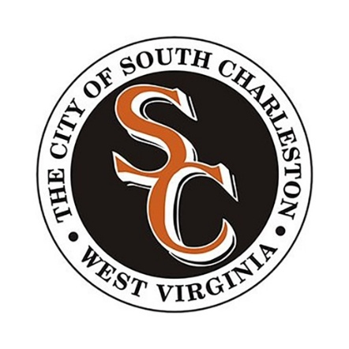

Online Business License Application and Renewal

- Go to https://southcharlestonwv.portal.opengov.com/.
- Under Department of Finance, click Explore.
- Select the appropriate application:
  - Municipal Business License
  - Contractor Business License (Contractors/Handymen)
  - Rental License (Landlords/Property Owners)
- Click Apply Online in the upper-right corner.
- Create a Permitting & Licensing account or sign in if you already have one.
- Complete the Contact Information section.
- Under Application Type, select New or Renewal.
- Complete the remaining sections and upload any required documentation.
- Click Confirm and Submit.
- Once City staff have reviewed and approved the application, the applicant will receive an email with payment instructions.
- After payment has been received, the business license will be available to print directly from the portal and will automatically be linked to the Tax Portal.

