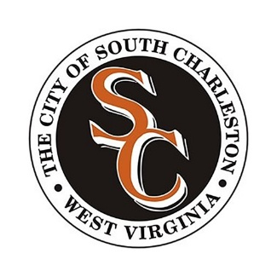

Municipal Service Fee & Commercial Refuse Fee Portal

- Go to southcharlestonwv.taxandrevenue.opengov.com.
- Click Register in the upper-right corner.
- Select Customer as the User Type and create an account.
- Log in to the Customer Portal.
- Under Getting Started, click Link Existing Records.
- Enter the PIDN and Security Code shown on your bill. The PIDN is your new account number and will begin with MSF- for Municipal Service Fee accounts or CRF- for Commercial Refuse Fee accounts. If you are unable to locate your bill, contact the Finance Office for a copy.
- Click Link.
- Your account will appear under Linked Records.
- Click the blue Pay button next to the PIDN to make a payment.
- To view additional account information, click the blue PIDN. From the account page, click the blue Actions button to:
  - View Past Receipts
  - View Current Charges
  - View Charge History
  - View Bills

